**Exercise 11:**

**AIM:**

To download the N-Stalker Vulnerability Assessment Tool and exploring the features.

1. Download and install N-Stalker

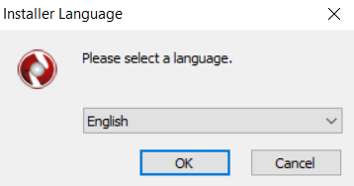

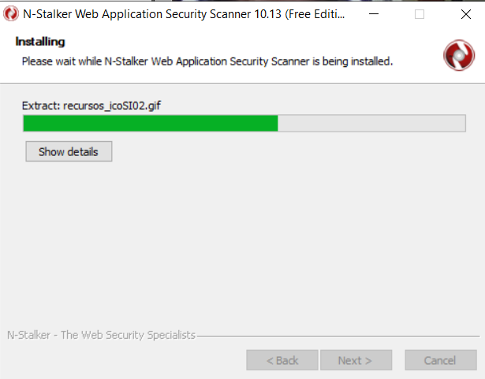

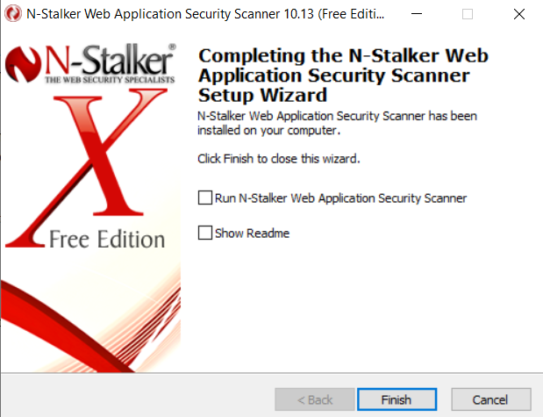

1. Click on “Scan ” and enter the target URL. In scan policy, you can select from the four options,

• Manual test which will crawl the website and will be waiting for manual attacks.

• full xss assessment

• owasp policy

• Web server infrastructure analysis.

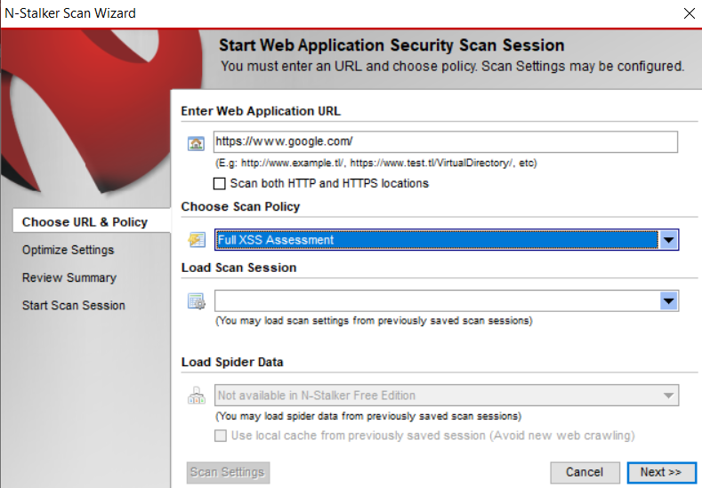

1. Once, the option has been selected, next step is “Optimize settings” which will crawl the whole website for further analysis.

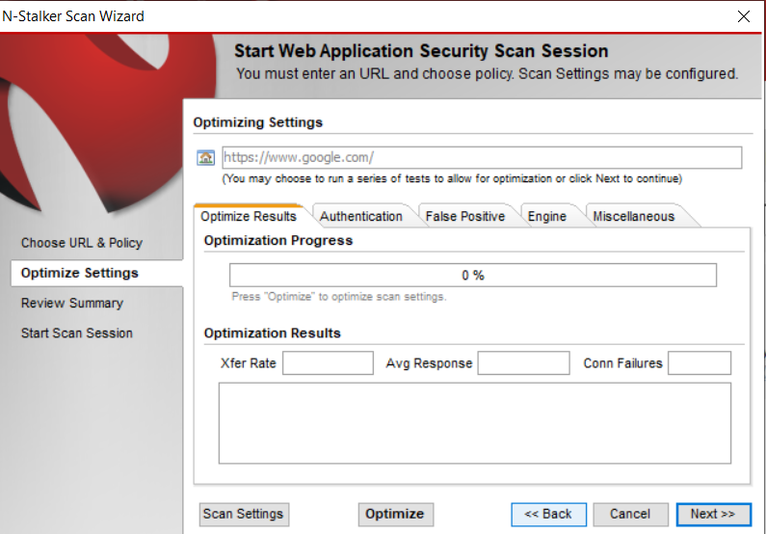

1. In review summary, you can get all the information like host information, technologies used, policy name, etc.

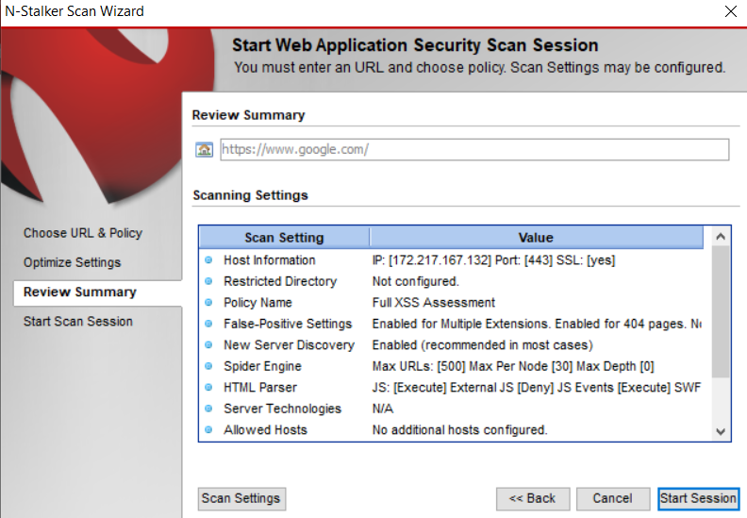

5) Once done, start the session and start the scan.

The scanner will crawl the whole website and will show the scripts, broken pages, hidden fields, information leakage, web forms related information which helps to analyze further.

Dashboard:

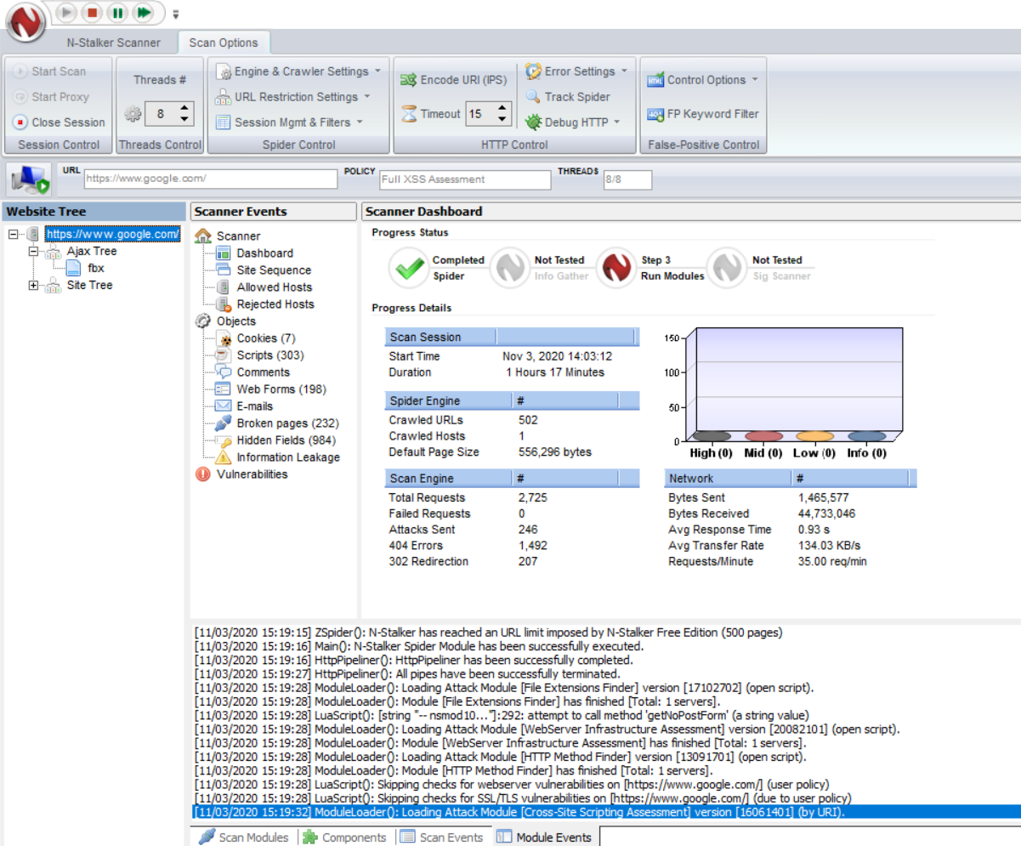

Site sequence:

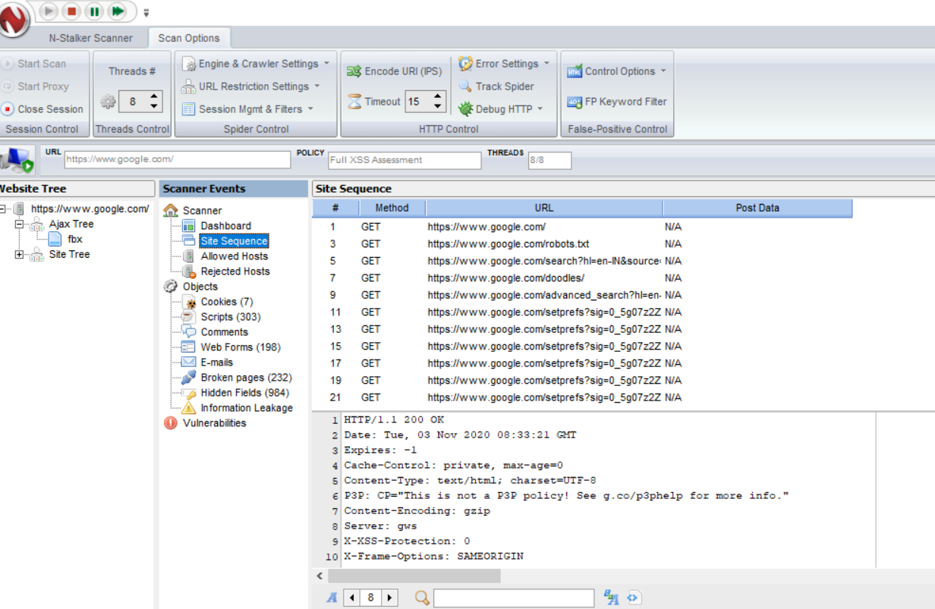

Cookies:

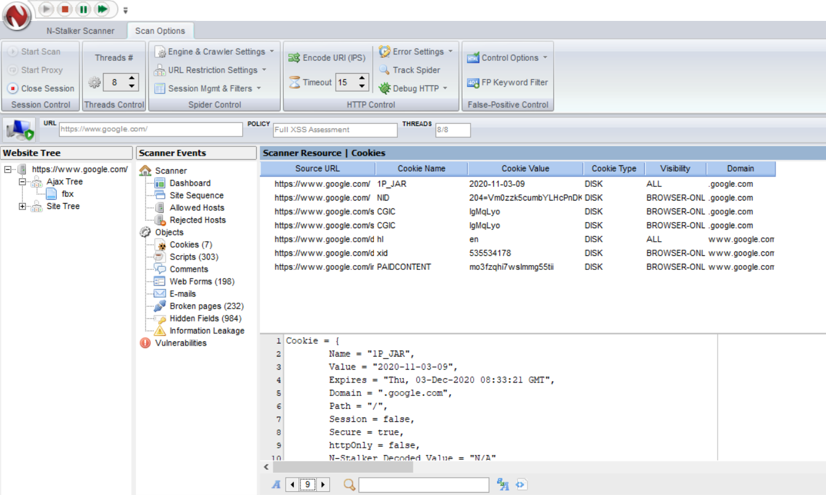

Scripts:

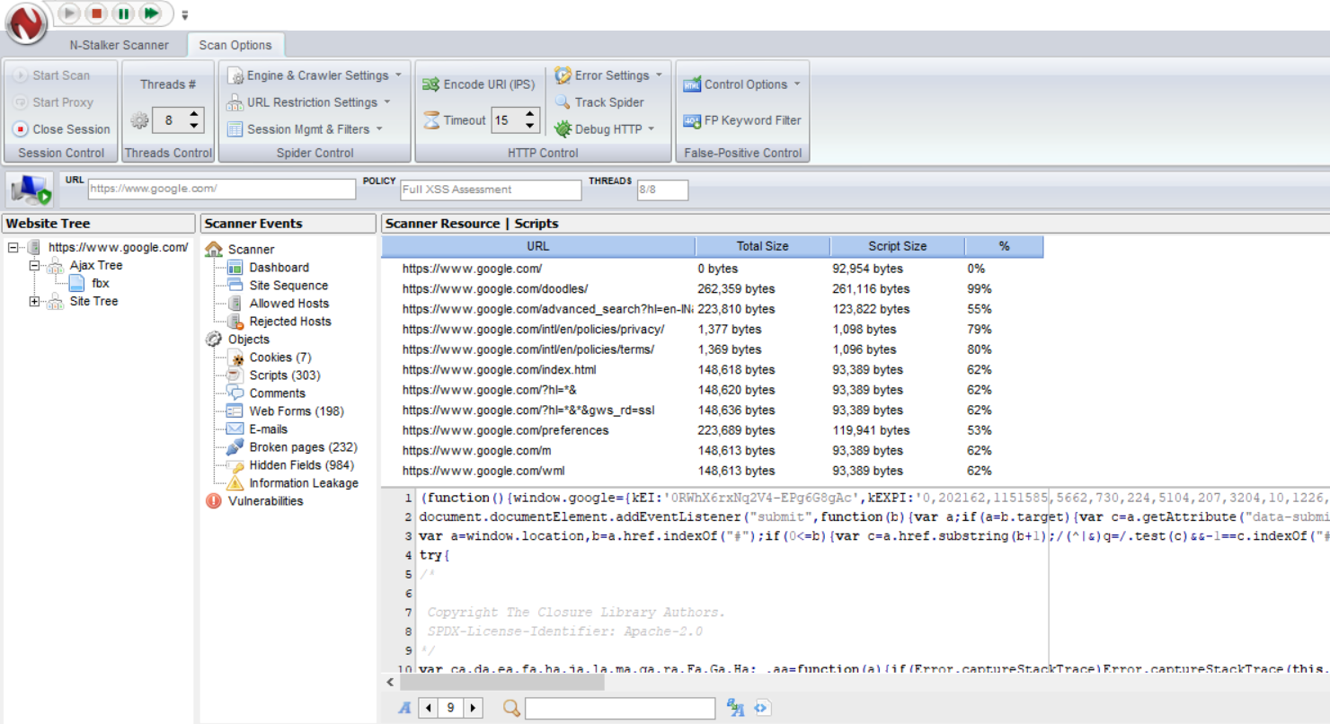

Web forms:

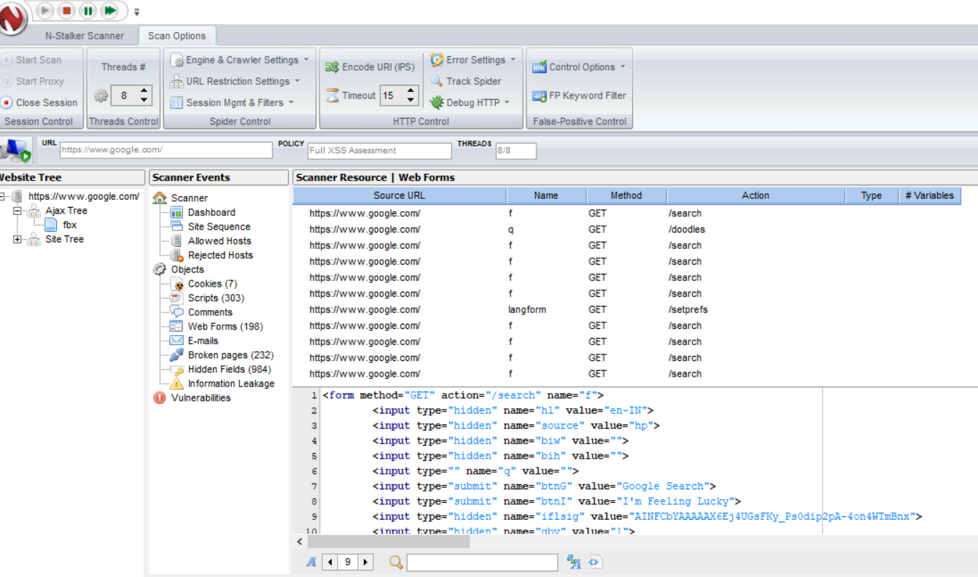

Broken pages:

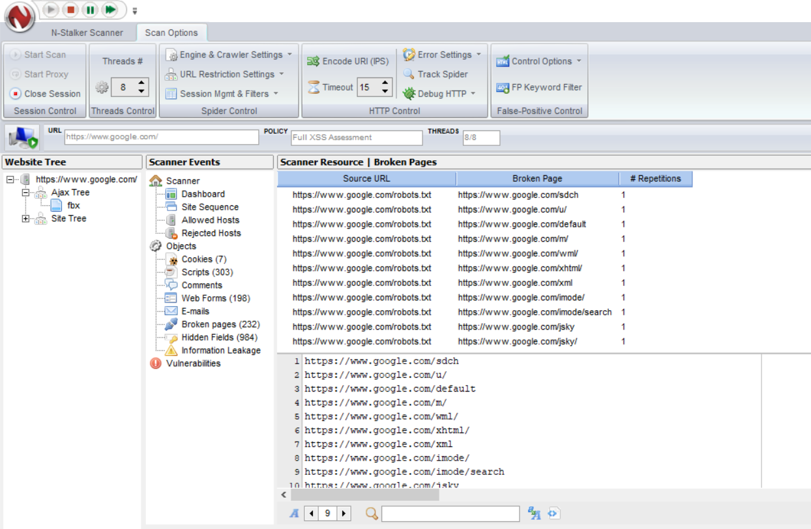

Hidden fields:

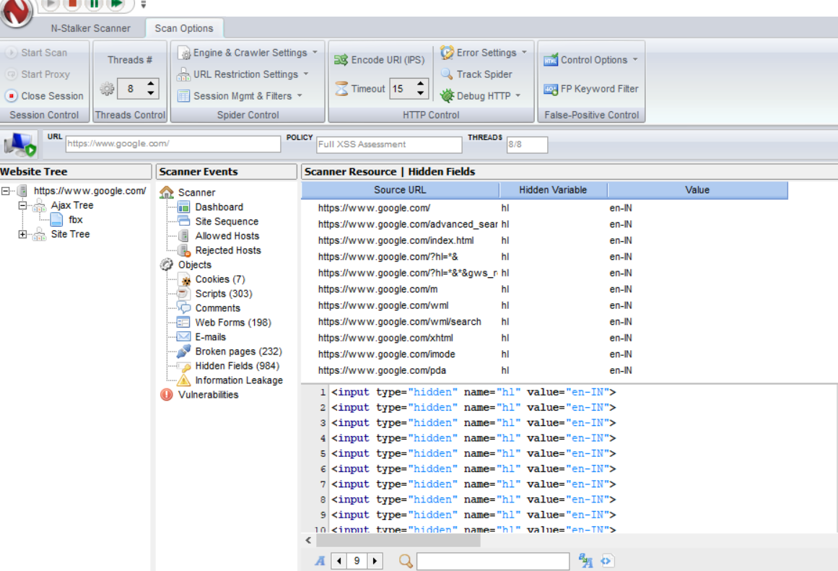

1. Scan completed successfully

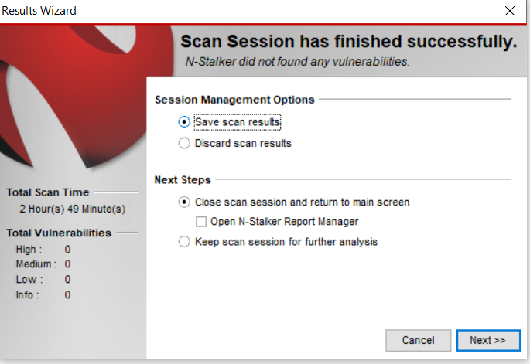

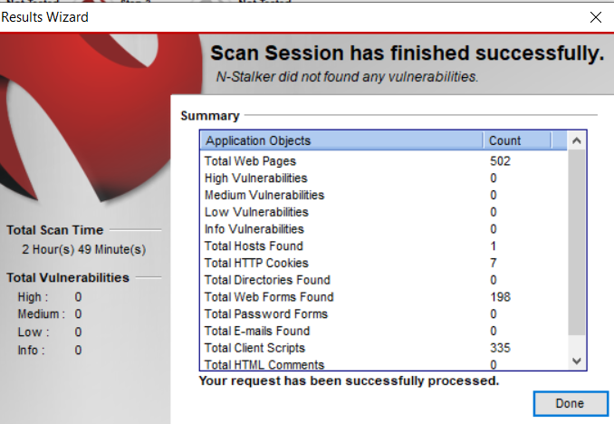

1. Report generation

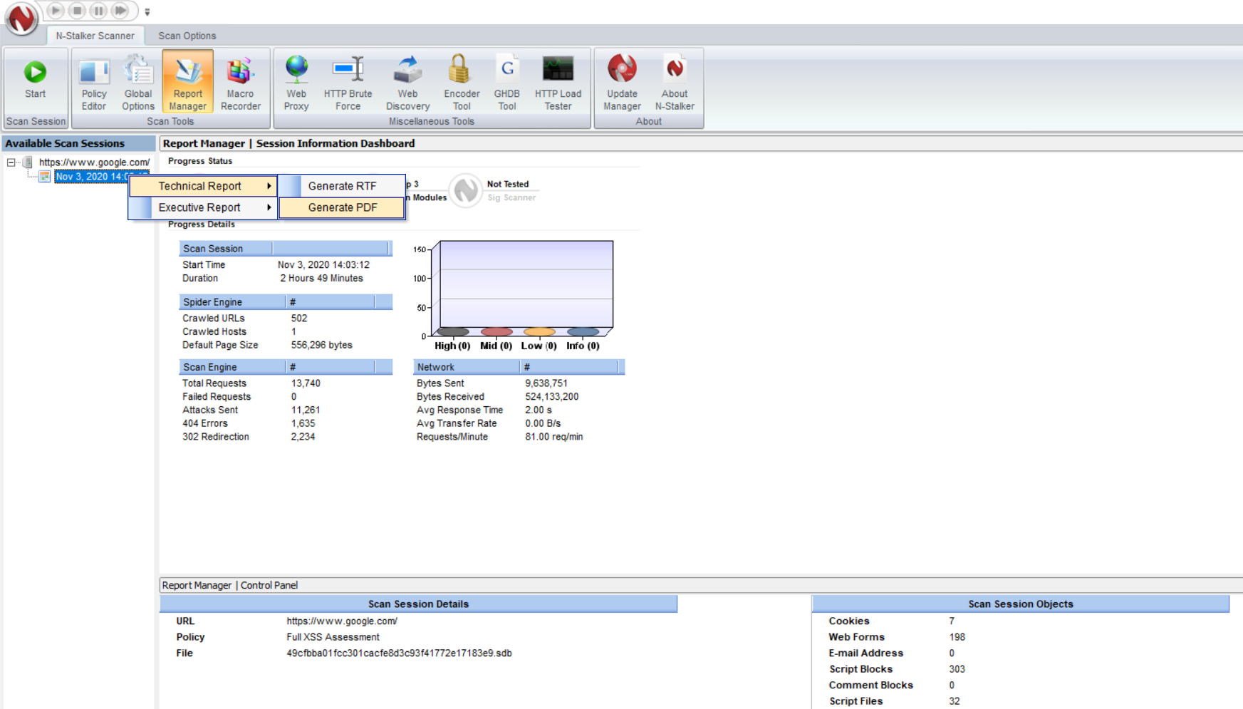

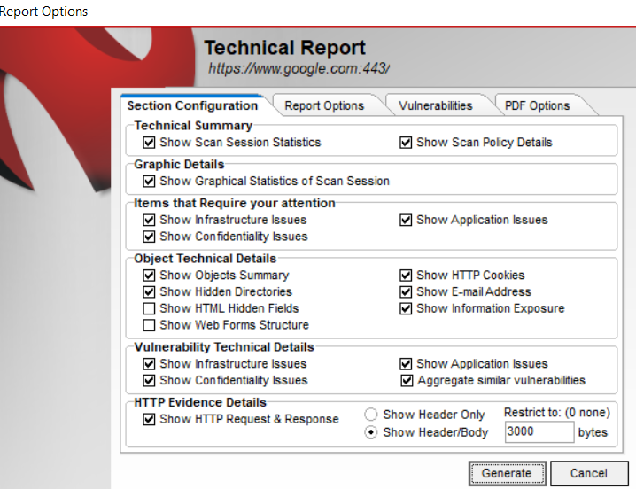

NSTALKER REPORT:

